WEEK-3 PRACTICAL
Task 3: Develop a C program using fork() that creates a parent and child process. Display the Process ID (PID), Parent Process ID (PPID), and process states at different stages of execution.
CODE: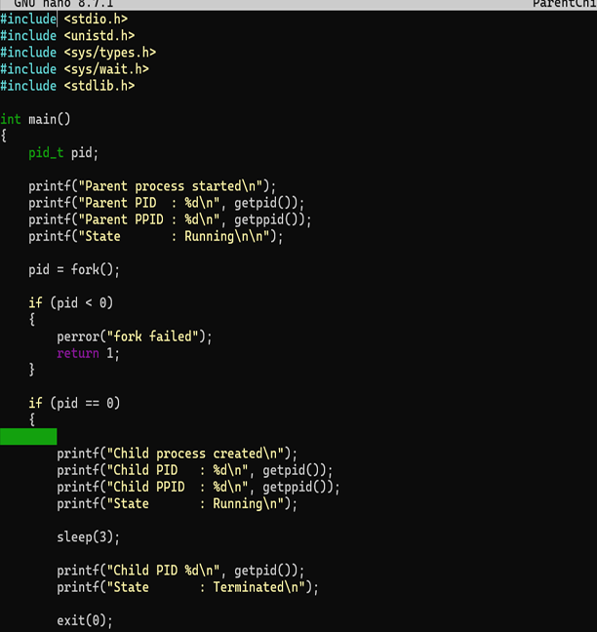
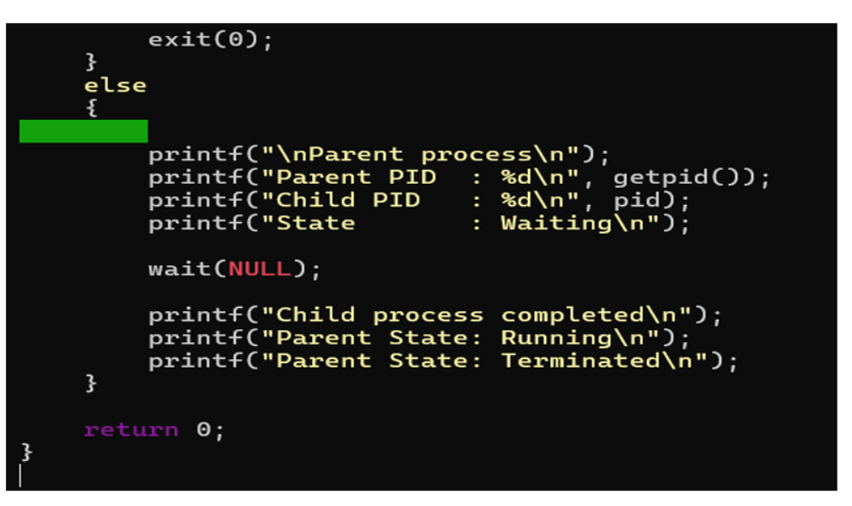
OUTPUT:
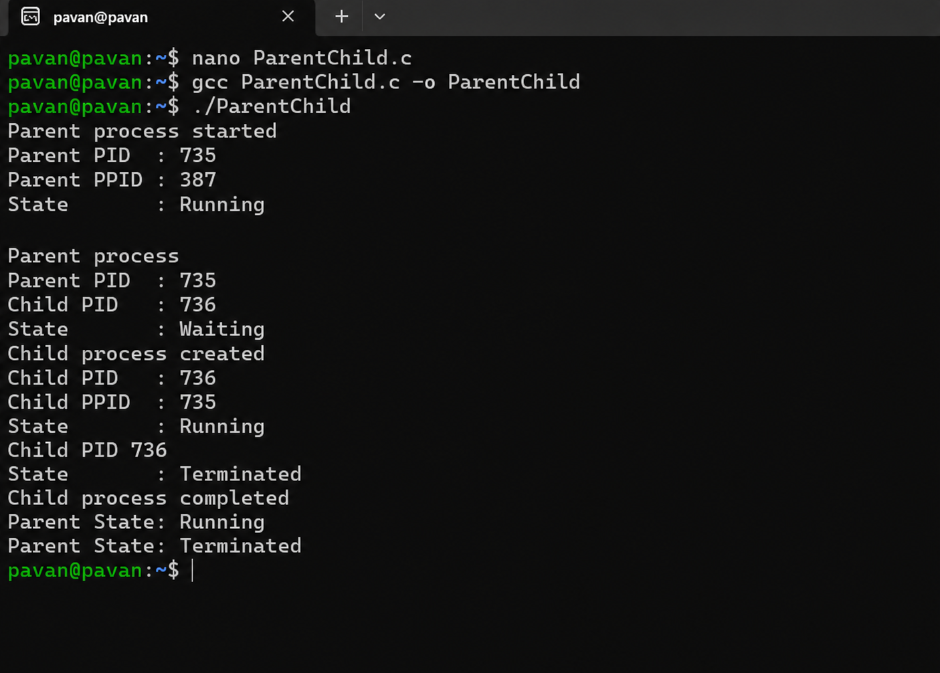

REPORT: The program successfully creates a child process using fork(). The PID and PPID of the parent and child processes are displayed, and the process states are observed during execution.

Task 4: Design an experiment to observe process state transitions (Ready, Running, Waiting, Terminated) using Linux monitoring tools such as ps, top, and /proc. Document the observations
CODE:
PS -EF: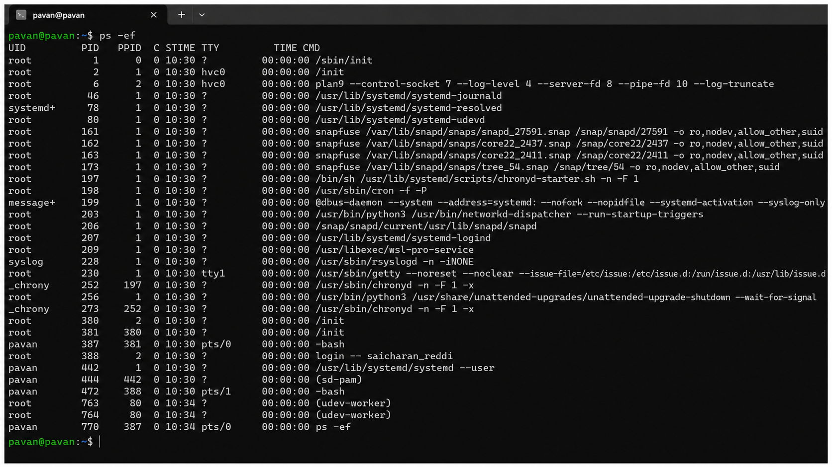

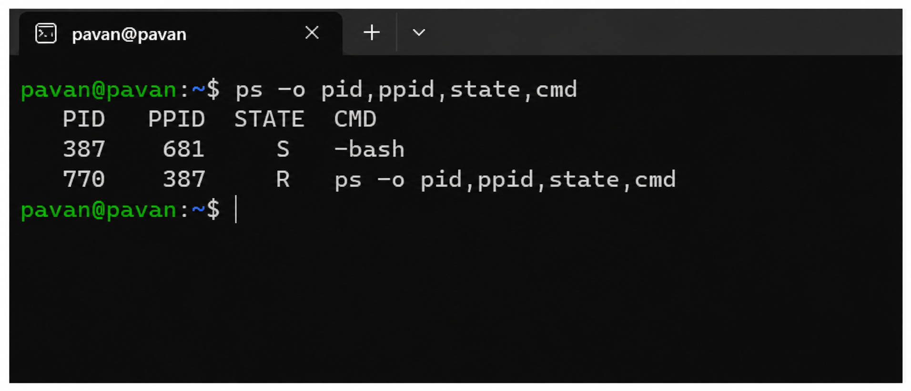

TOP:
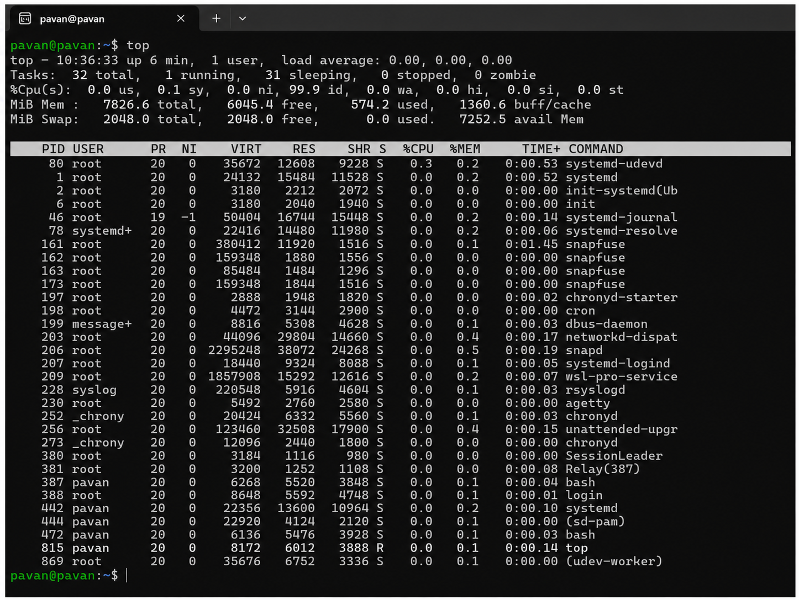

REPORT: This is understanding process creation and process state transitions in Linux. The fork() system call was used to create a child process, while ps, top, and /proc were used to monitor process information and states. The PID and PPID helped identify the relationship between the parent and child processes.

